Project Title: INVENTORY for PRODUCTS DATA SET
Project Objective:
The given DATA SET is about the product list of particular brand. Need to find the total numbers of items present in the dataset, total cost of whole products and

Dataset Description:

Column Description:
Column Name | Description
Product ID | Product code
Product Name | Electronics, kitchen,
Product price | In $
quantity | How many each product in numbers

Data cleaning & transformation:

Visualization and Insights Arrived with screenshot of visualization
RAW (ORGINAL) PORDUCT DATASET
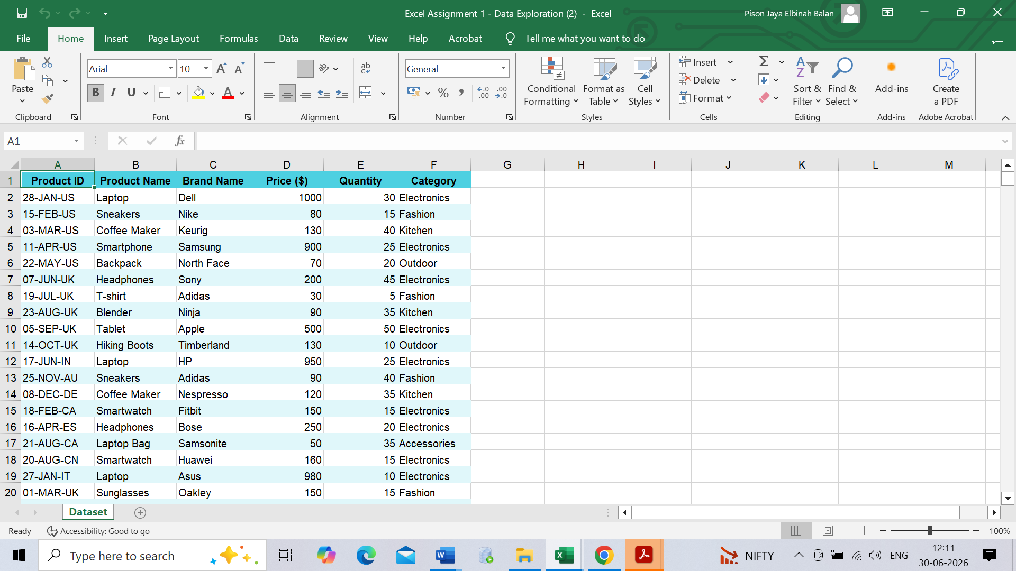

Calculated results for each function
SUM, COUNT, AVERAGE:
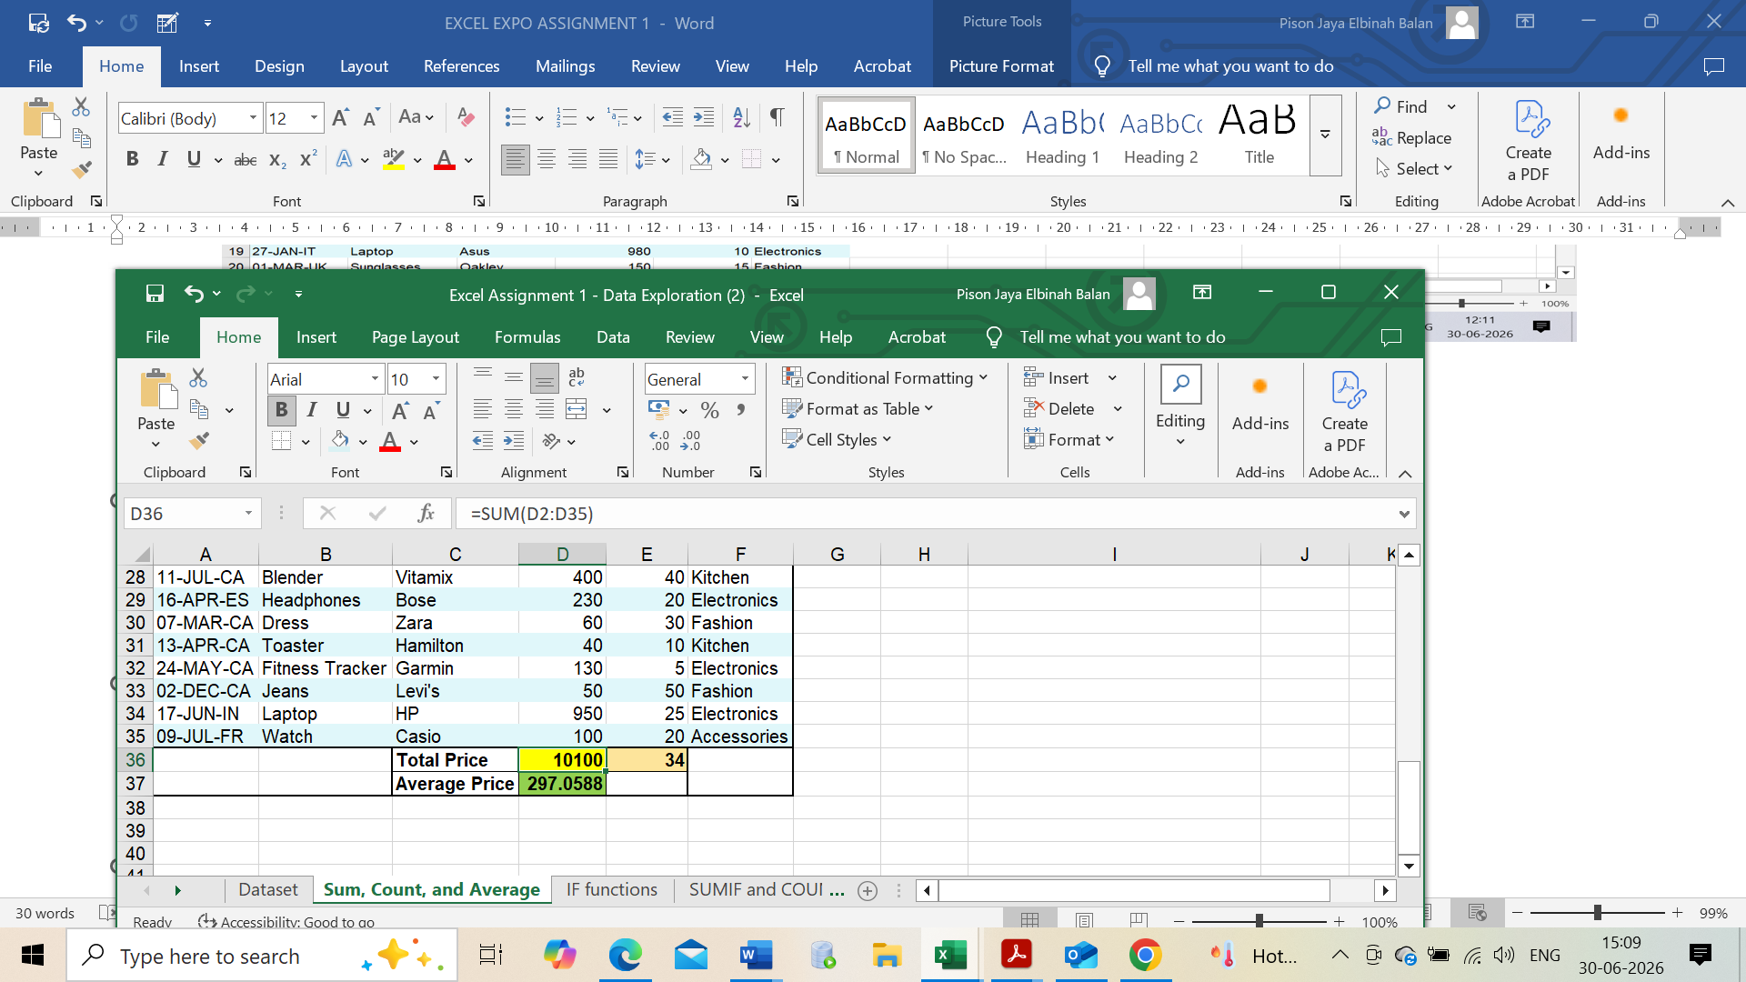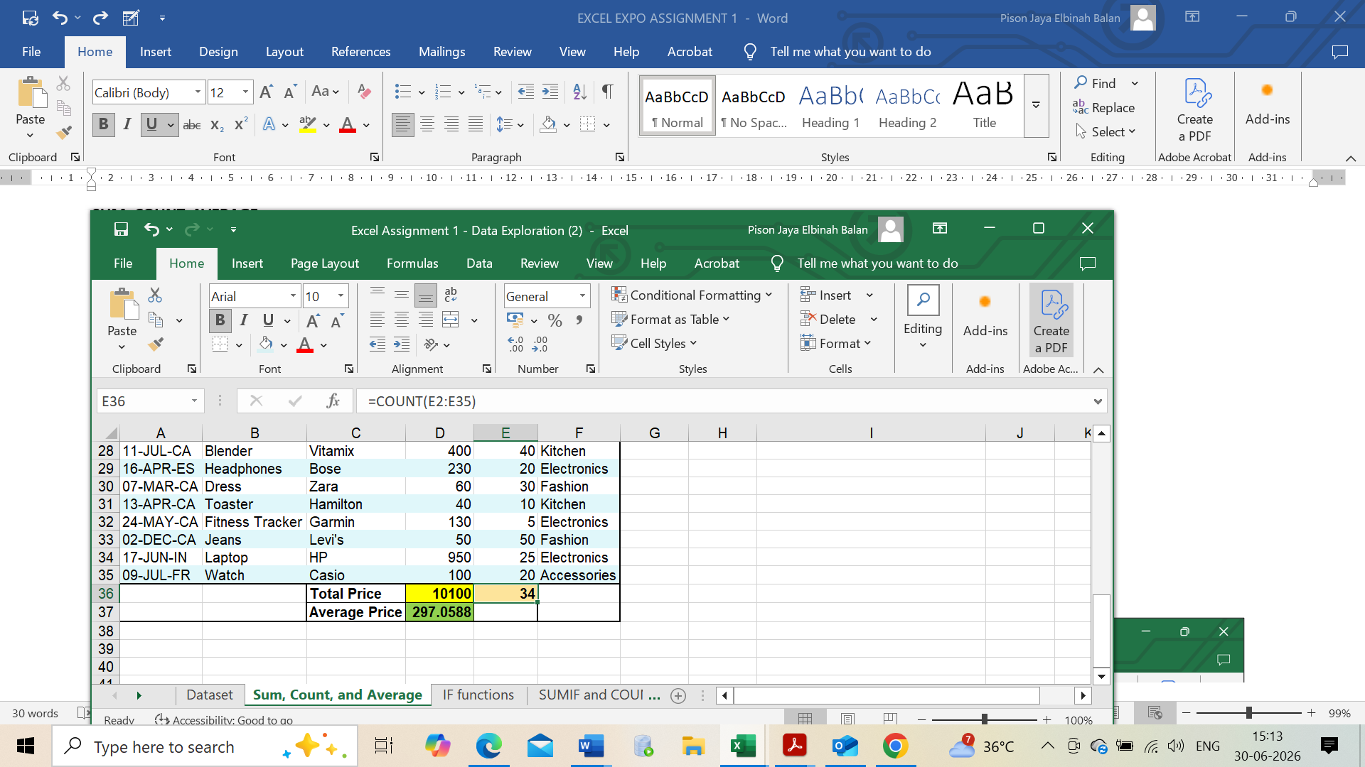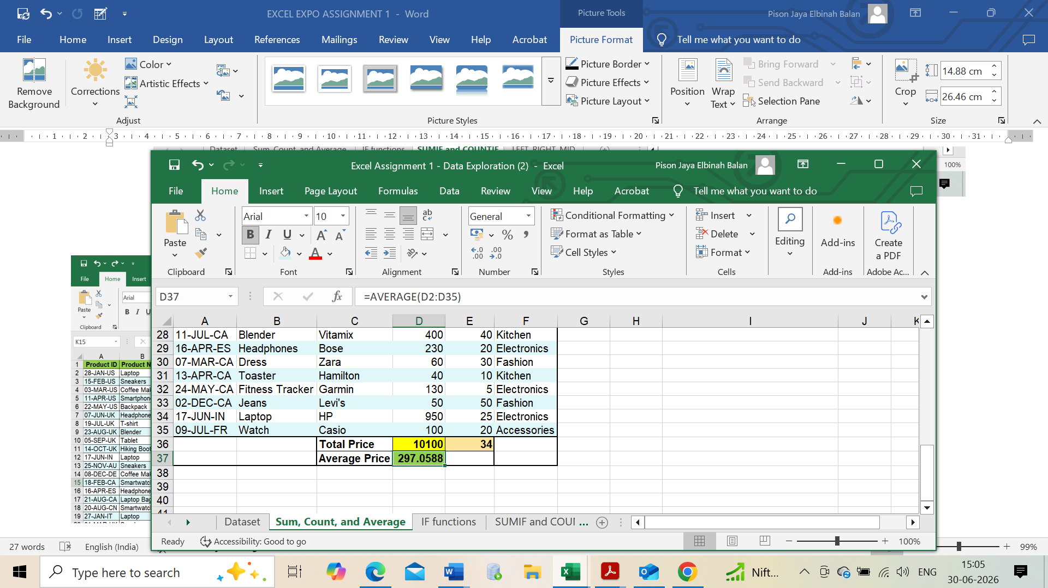

- MIN function:
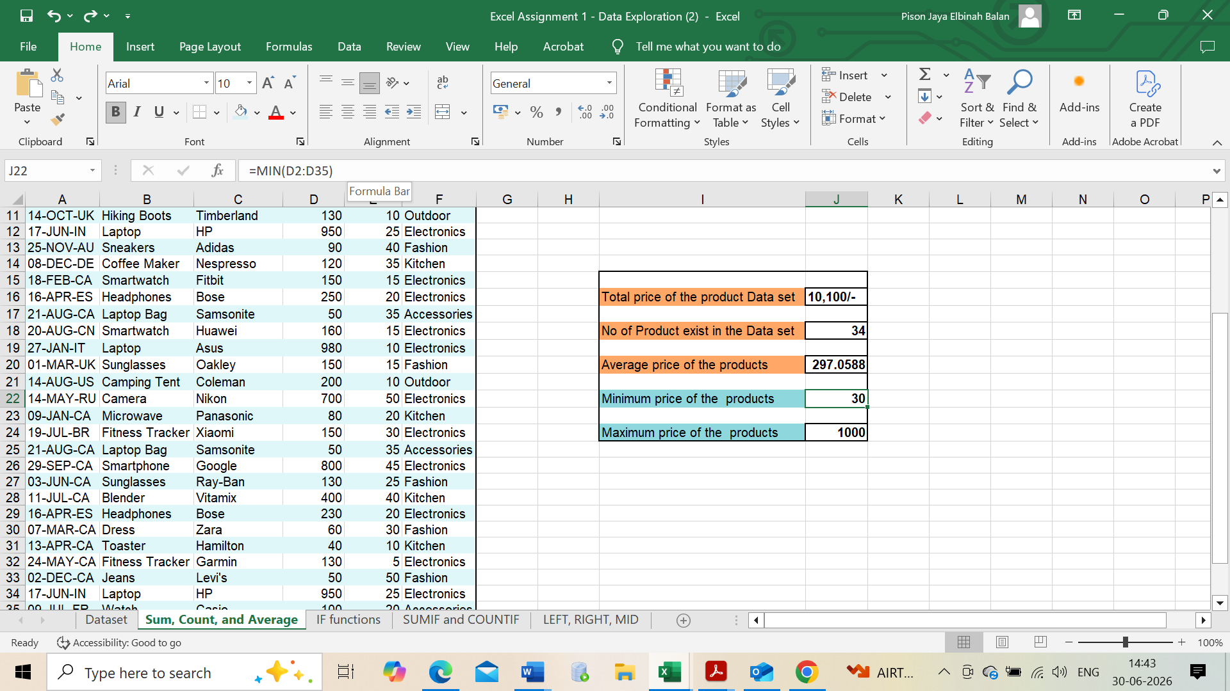
- MAX function:
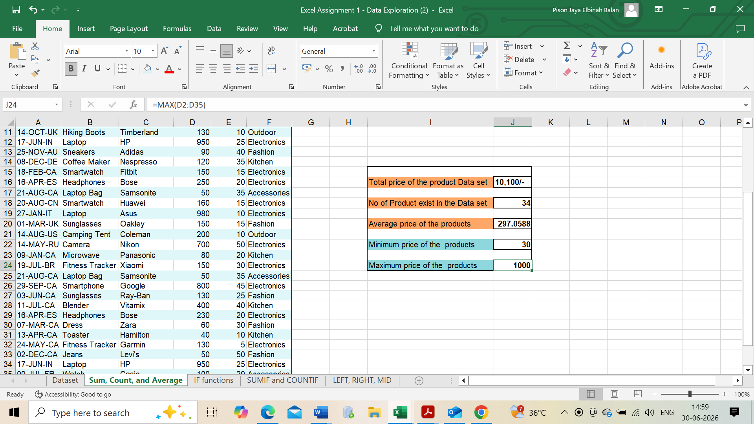
- used the format painter IF function:
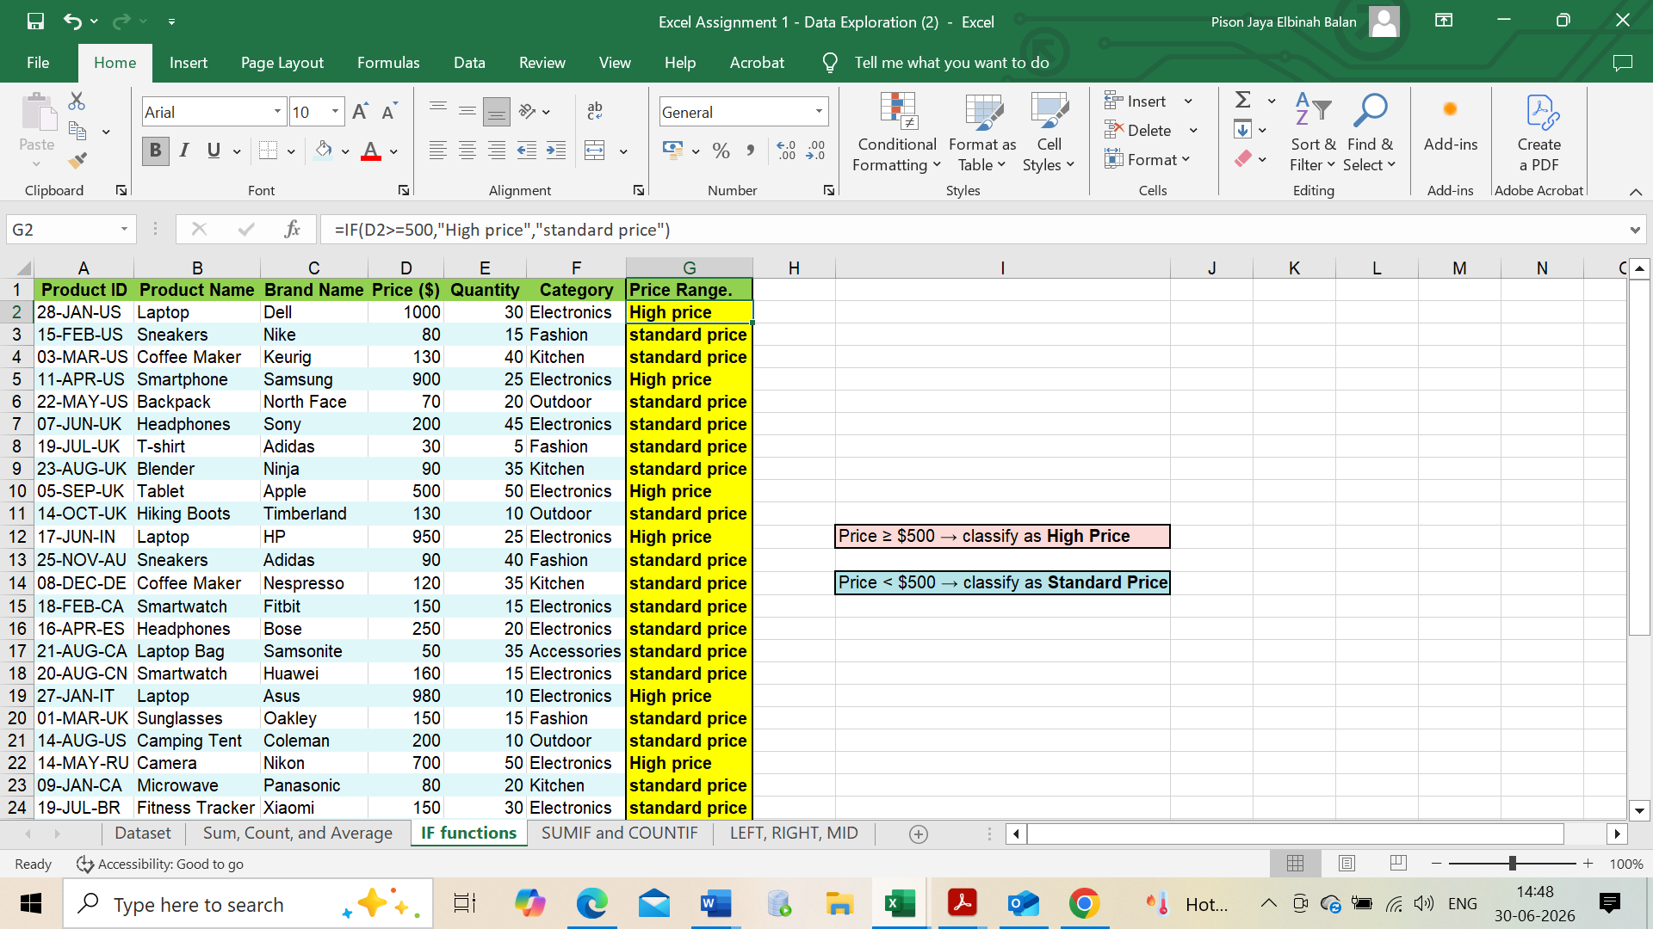

- used the SUMIF function
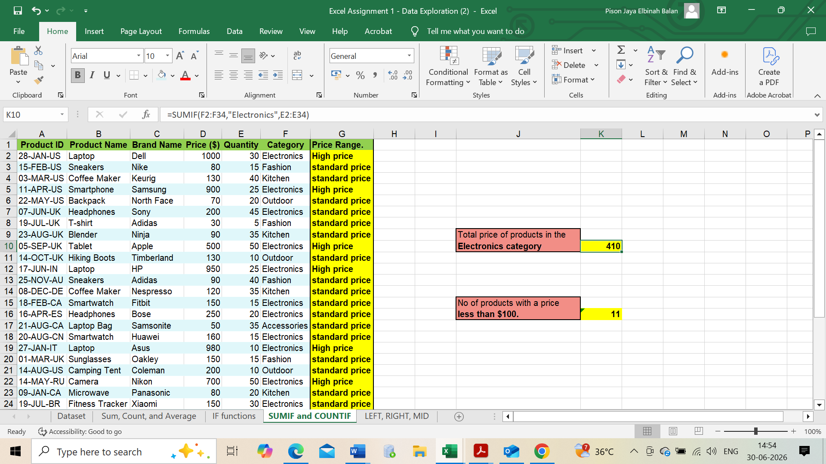

- Used COUNTIF Function:
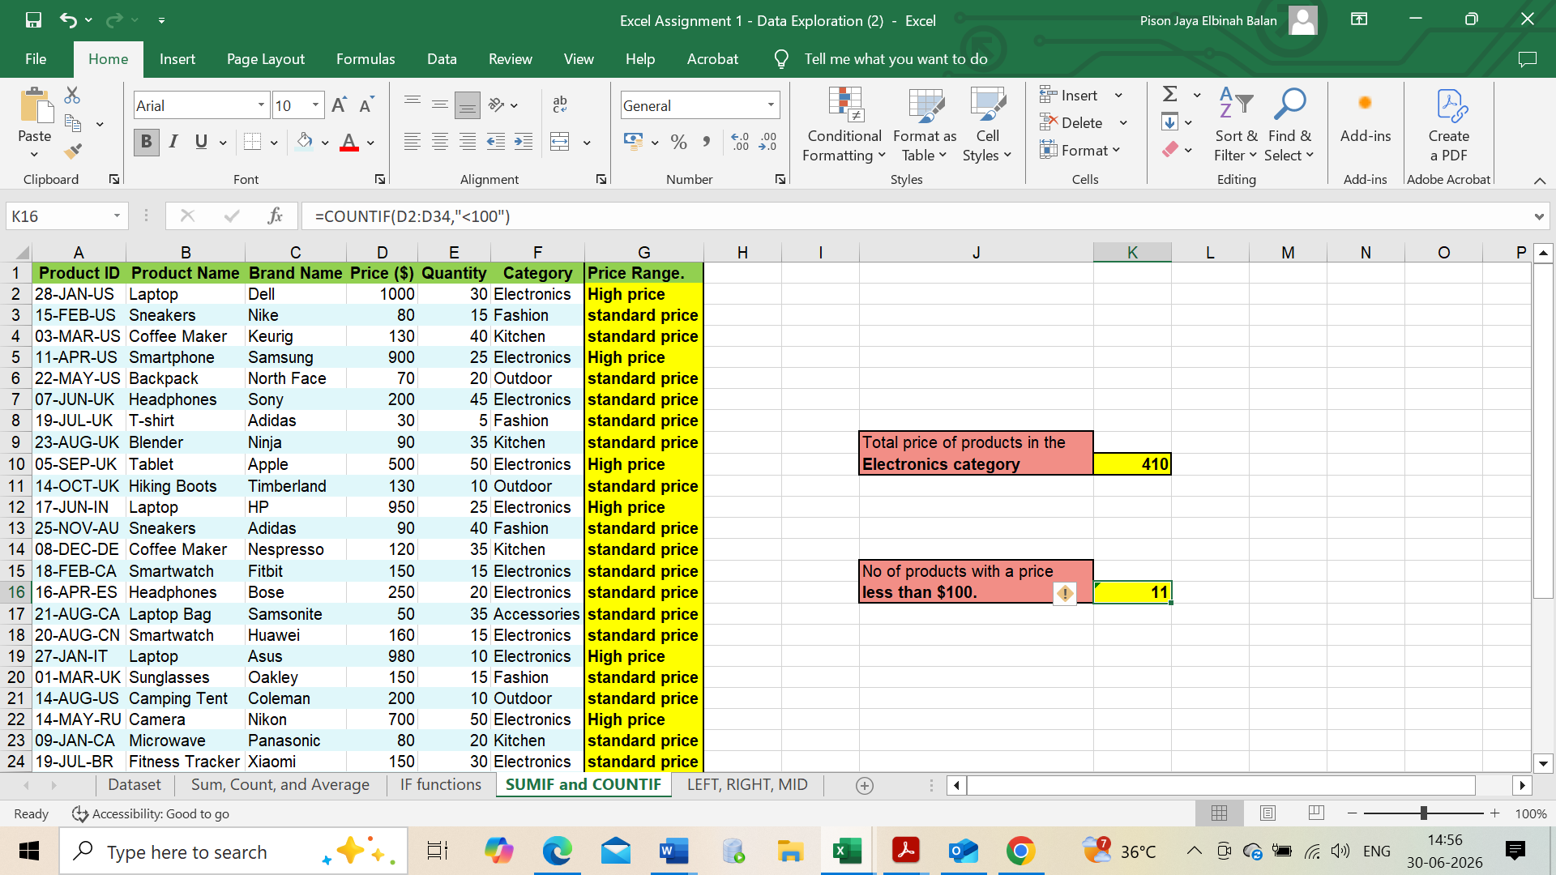
- Text Formatting – LEFT, RIGHT, MID
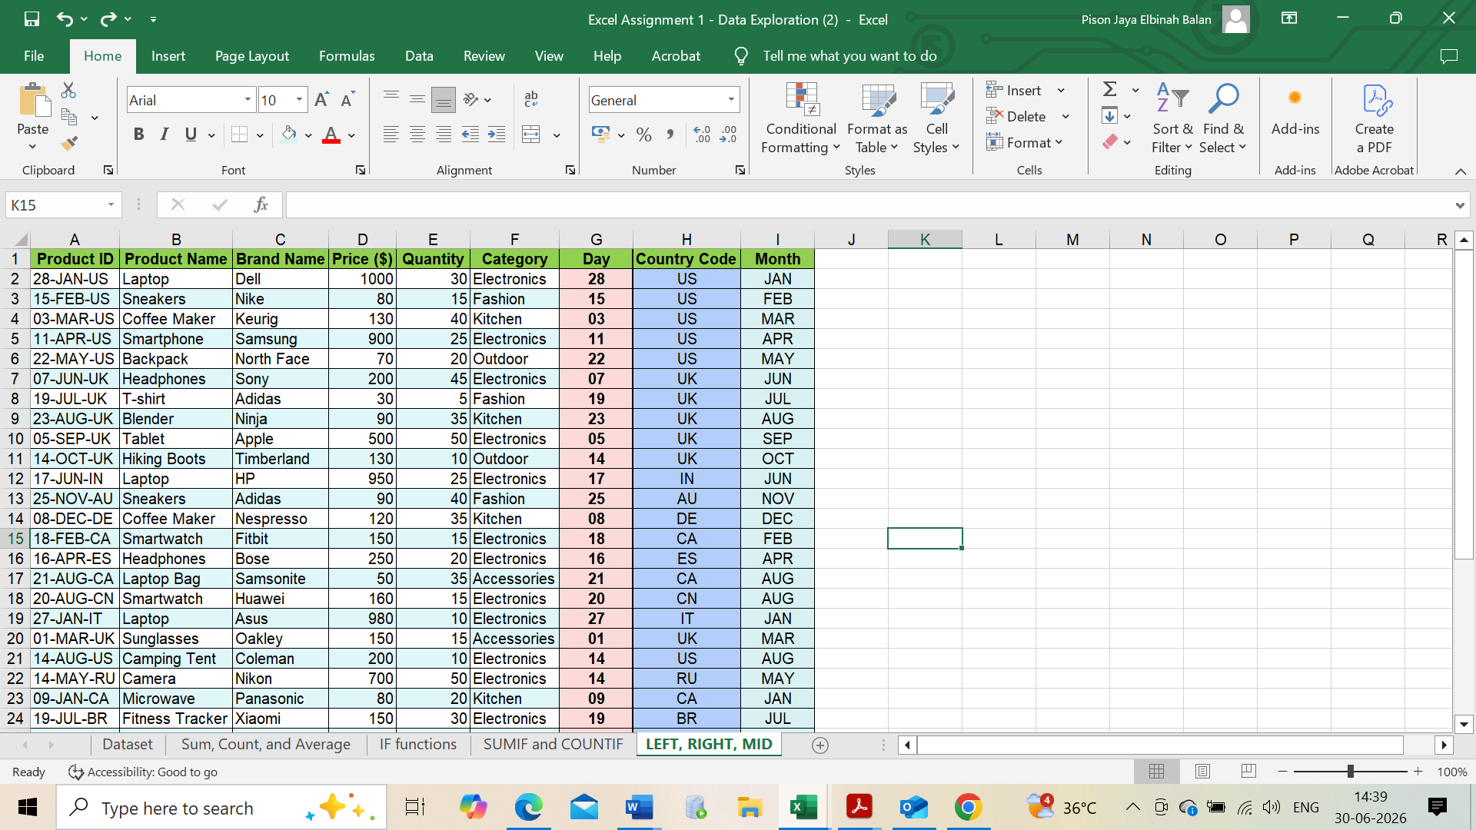

Conclusion: Analysed the Raw data and create anew columns of rang price, product code with Day, month and country code. So find the total sum of the products, MIN and MAX of products. Average of the products and performed the conditional function and Text formatting function.

